Learning Diary

Sadia Munye

2025-01-21

Table of contents

# Welcome

Hello! Welcome to my remote sensing learning journey. This is the module I have been excited about the most all year as the idea of using satellite imagery (data I’ve never used before) just sounded very cool. I’ll admit I am a bit nervous as although I am familiar with geographic data science techniques from my previous casa modules, it feels like remote sensing will include a lot more maths and science, which isn’t my strong suit (quite ironic as I’m taking a spatial data science masters degree).

**Anyway a bit about my background:**

I am undertaking a part-time masters here at CASA while working for the London Borough of Tower Hamlets as a apprentice data scientist and I previously graduated with BSc in geography. I would say that my job is ideal and I love the fact that I can study but also apply what I have studied on the job. I am also really excited to find potential use cases for remote sensing in the council.

**I hope to take a few things out of this module:**

1. Gain a better understanding of remote sensing and applications (where it is and isn’t useful).
2. Understand how to process and analyse remotely sensed data.
3. Learn how to build professional websites using R and quarto.
4. Find questions that can be solved in the council using remotely sensed data.

This is a Quarto book.

To learn more about Quarto books visit <https://quarto.org/docs/books>.

# 1. Week 1 - Getting started with remote sensing

## 1.1 **Summary:**

Going into the first week of remote sensing I wasn’t sure what to expect. All I knew is that it had something to do with satelites and people way smarter than me.

This week I learned that remote sensing is a powerful method of collecting data by measuring the reflected and emitted radiation of an area (USGS, 2024). The sensors used for gathering this data can be mounted on various platforms including satellites, planes, drones and even… mobile phones.

### 1.1.1 Remote Sensing Applications in Earth and Ocean Observations

|  |
| --- |
| Satellite and Airplane Imaging |
| Cameras on satellites and airplanes take images of large areas on the Earth’s surface. This technology provides the ability to monitor vast landscapes and track changes over time, which is especially useful for environmental studies, urban planning, and disaster management.  Source:[Industry tap](%22https://www.industrytap.com/remote-sensing-sustainable-land-use/33218%22) |

|  |
| --- |
| Sonar Systems for Ocean Floor Imaging |
| Sonar systems on ships can be used to create images of the ocean floor without needing to travel to the bottom of the ocean. These systems emit sound waves that bounce off the ocean floor, providing detailed images of underwater features, such as seafloor topography and submerged objects, aiding navigation and marine research.  Source:[divediscover](%22https://divediscover.whoi.edu/archives/ventcd/vent_discovery/deeperdiscovery/tools_sonar_singlebeam.html%22) |

|  |
| --- |
| Satellite Imaging for Marine Biological and Physical Variables |
| Cameras on satellites can be used to make images of biological and physical variables in the oceans. This includes observing sea surface temperature, chlorophyll-a concentrations, and ocean color. These images allow for the monitoring of marine ecosystems, tracking biological productivity, and understanding the impacts of climate change on ocean health.  Source:[Marine Biological Observation Network](%22https://www.researchgate.net/figure/Satellite-remote-sensing-and-the-Marine-Biological-Observation-Network-Red-squares_fig1_356094764%22) |

### 1.1.2 Spectral resolution

During this week’s lecture, we covered spectral resolution, which I found interesting as it was a new concept to me.

It measures specific wavelengths of light across the electromagnetic spectrum (something I haven’t covered since GCSE physics..), which allows features like water, soil, and vegetation to be distinguished by their unique spectral pattern.

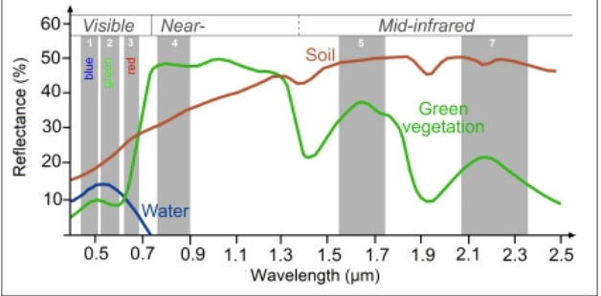

Source:[Science Education through Earth Observation for High Schools](%22https://seos-project.eu/classification/classification-c01-p05.html%22)

Different sensors are designed with different spectral resolutions.

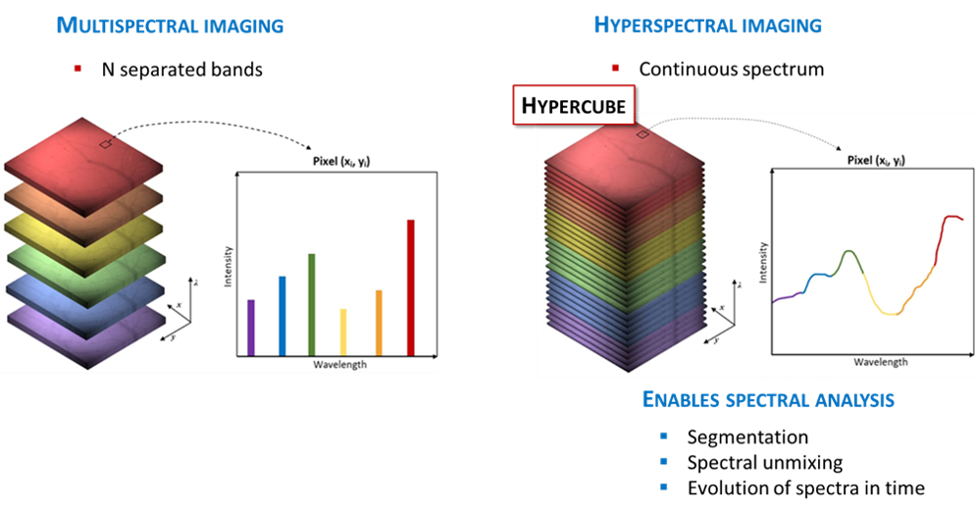 Source:[nireos](%22https://nireos.com/application/what-is-hyperspectral-imaging/%22)

Multispectral sensors capture a few broad spectral bands (3–10), mainly visible light and some non-visible bands including infrared. They are simple so therefore cost-effective and suitable for large-scale monitoring such as distinguishing forest from water, but their broad bands can obscure finer differences, such as between tree species or in water quality.

Hyperspectral imaging captures data in hundreds of narrow adjacent spectral bands. This allows for finer distinctions, such as between tree species or specific water pollutants. However, this detail comes at the cost of greater complexity and large datasets that are more demanding to process. Due to this, hyperspectral imaging is less suitable for continuous global monitoring.

### 1.1.3 What I make of this:

I currently work for the London Borough of Tower Hamlets, where the mayor has declared a waste emergency and the borough is currently the worst in the country for recycling. After conducting some further research I found that hyperspectral imagery would be very useful in this case to potentially detect and classify the types of contamination present in recycling loads [(Taneepanichskul et al., 2025)](https://journals.uclpress.co.uk/ucloe/article/id/3237/). However, this would require the purchasing of a hyperspectral camera. Likewise, I don’t know much about classification yet so I’ll see if i still think this in week 6…

## 1.2 **Applications:**

In the practical we used data from two multispectral sensors (Landsat 8 & Sentinel 2).

|  |
| --- |
| Landsat 8 |
| Landsat satellites detect earth data while in orbit at a 30m resolution and have been providing the longest continuous Earth Observation record dating back to 1972. |

|  |
| --- |
| Sentinel 2: |
| Whereas, Sentinel 2 (Beginning 2015) are a pair of satellites that monitor the earth’s land surface at a higher resolution (10-60m). |

From the practical, the differences between Sentinel-2 and Landsat were clear. The contrast in imagery from the Landsat and Sentinel-2 can differ, and this is due to the differences in their sensor characteristics and processing methods. Landsat provides a 30 meter spatial resolution and Sentinel provides as high as 10 meters for certain bands. I was really confused from the practical why the images were so different. However it’s also because you might not be able to get an image from the exact time and day for both satellites.

**Note: The Sentinel-2 data was resampled to 30m to match landsat**

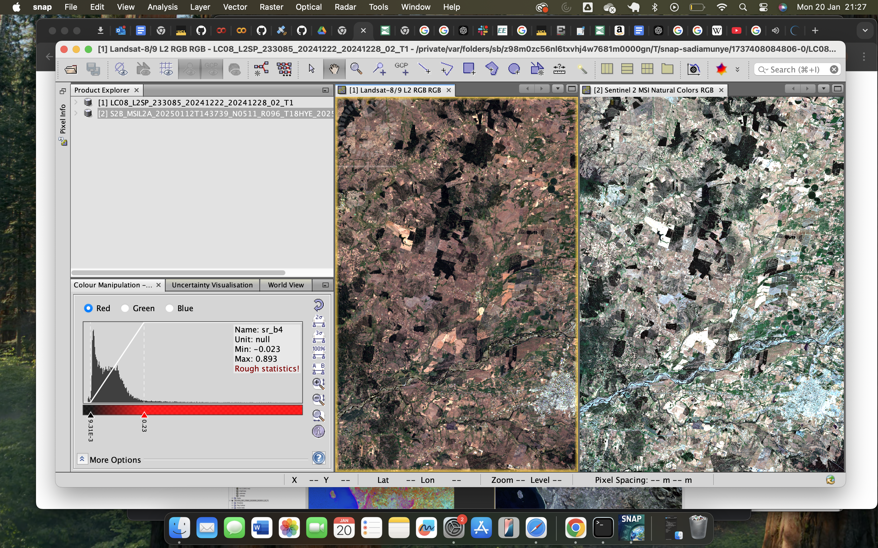

Before colour manipulation in snap

This is how it looks after I used the colour manipulation which is adjusting how spectral bands are displayed as colours. A bit like using a snapchat filter the image is the same, but we can change the colours to highlight different details.

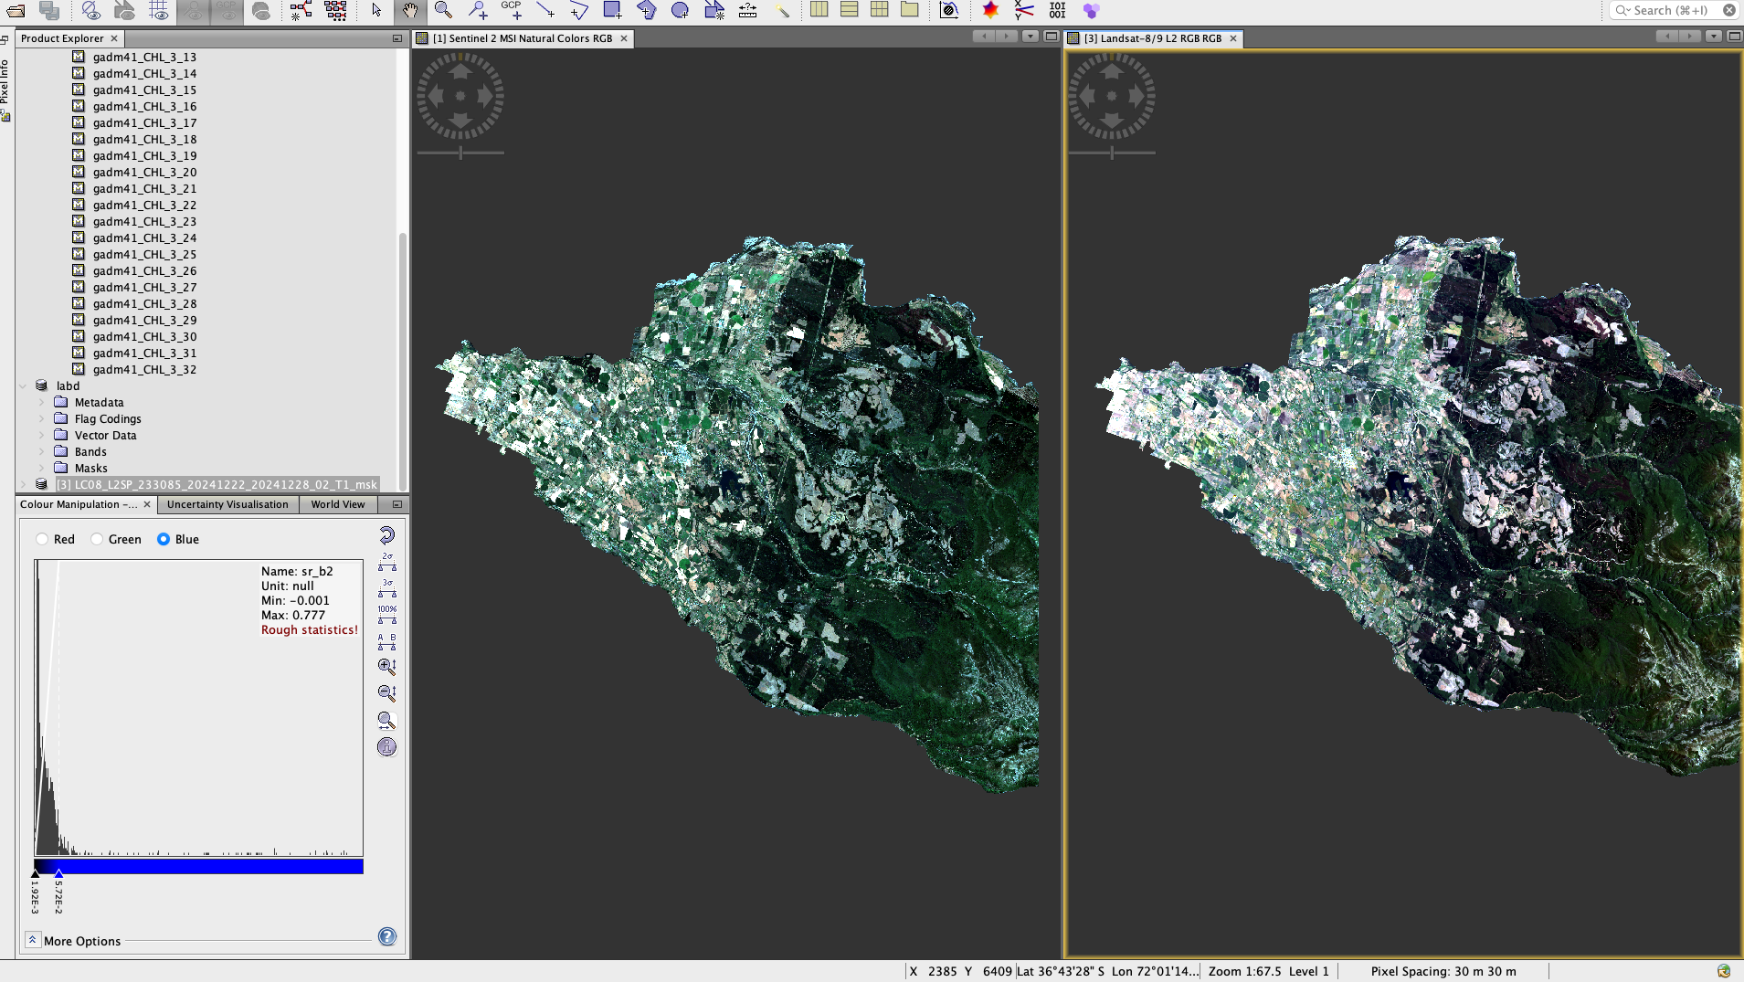

After colour manipulation in SNAP

### 1.2.1 **Combining Landsat and Sentinel-2 data to assess burn severity**

Quintano et al. demonstrated that combining landsat and Sentinel-2 data can significantly enhance research. The study used Landsat 8 images taken before the fire to measure vegetation health using the Normalised Burn Ratio, then compared them with images taken after the fire from either Landsat or Sentinel-2. This showed how much the vegetation changed, allowing the resarchers to map the severity of the burn in a consistent way.

Landsat offered a long-term archive and established indices for assessing burn severity. While Sentinel-2’s higher spatial resolution and increased revisit frequency allowed more detailed assessments and quicker data availability, which are particularly valuable during fire emergencies. Likewise, when pre-fire Landsat data was unavailable, Sentinel-2 alone still offered a useful approximation of fire impact. The researchers suggest that future work should focus on fine-tuning these methods to improve accuracy, especially for less severely affected areas, which would help rescue teams and forest managers respond more effectively to fire emergencies.

However this integrated approach is a great step to enhancing fire management by offering a more immediate and accurate understanding of the extent and severity of the burn.

## 1.3 Reflection:

My views on remote sensing have definitely changed. During my undergraduate degree I was always scared to choose any remote sensing modules as I was always warned about how difficult they were. This week, I began to see how it connects to everyday problems and decisions. The ability to extract patterns from imagery whether through hyperspectral or multispectral imagery made me think about how often we overlook information that is literally all around us, waiting to be seen.

I found the contrast between different satellite systems interesting. Initially, I was frustrated by the inconsistencies in the imagery and assumed that I was doing something wrong. However, this helped me realise the importance of evaluating data critically rather than accepting it at face value. This feels relevant beyond remote sensing, reminding me that any dataset is shaped by how it was collected, processed, and presented.

I’m looking forward to the upcoming weeks, to really get into detail about how remotely sensed data is currently used for research and policy. Even though my background is not in physics or earth sciences, I can already imagine links with waste management, and environmental policy. The possibility of using spectral patterns to identify waste materials makes me consider how remote sensing could provide valuable evidence for local councils. Though that also raises the question of data availability, there’s only so much open data out there and local governments do have a relatively limited budget. I’ll definitely look into whether the council has any access to remotely sensed data or if they have ever used remotely sensed data for analysis.

## 1.4 References

Taneepanichskul, N., Hailes, H. C. and Miodownik, M., (2025). Using hyperspectral imaging and machine learning to identify food contaminated compostable and recyclable plastics. UCL Open Environment 7, 1.

USGS (2025). What Is Remote Sensing and What Is It Used for? [online] www.usgs.gov. Available at: <https://www.usgs.gov/faqs/what-remote-sensing-and-what-it-used.>

Quintano, C., Fernández-Manso, A. and Fernández-Manso, O. (2018). Combination of Landsat and Sentinel-2 MSI data for initial assessing of burn severity. International Journal of Applied Earth Observation and Geoinformation, [online] 64, pp.221–225. Available at: <https://www.sciencedirect.com/science/article/pii/S0303243417302039>.

# 2. Week 2 - Xaringan and Quarto

## 2.1 Presentation

This week we were taught how to use Xaringan to create presentations and Quarto to create our learning diary portfolio. This weeks entry contains a short presentation I have created on the hyperspectral sensor hyperion.

⛶ Expand

## 2.2 Reflection

After some time playing around with these tools I was able to do some really cool things like create panels in presentation slides (which ultimately reduces the ammounts of slides that need to be used). I can also see using quarto as being a large part of my career as a few of the data visualisations at the council are created using quarto markdown documents for instance the reporting of the annual resident survey results. Also, for some time now, the quarterly performance reports have been created manually in PowerPoint (which usually takes the whole quarter). Injecting the data into a qmd would definitely speed up the process and is something I am looking into now.

# 3. Week 3 - Corrections

## 3.1 **This week I discovered that there are many ways to correct data….**

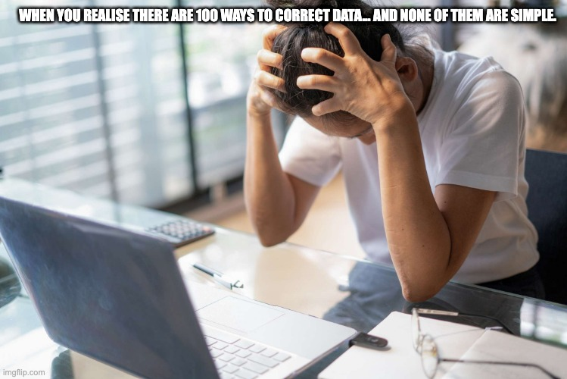

Honestly this is the most I have been confused in this module I am lost for words… so I will attempt to summarise it as best as I can.

Luckily for me most of the data that I’d use would come analysis ready however in a situation where I am dealing with raw data I would need to correct it. I understand corrections to be adjusting raw sensor data to remove potential flaws in atmospheric conditions, spatial inaccuracies and topographical variations.

More often than not remotely sensed data contains flaws.

A famous example is when the landsat scan line corrector failed, without the landsat corrector we got zig zags and a misaligned image.

### 3.1.1 **Examples of corrections:**

In this weeks lecture we covered numerous methods of correcting remotely sensed data and according to Google AI there are hundreds. so I will be going through the 4 main methods. Here is a table i complied using notes from the lecture and further reading.

| Method | Explanation | Strengths | Limitations | Use Case |
| --- | --- | --- | --- | --- |
| **Geometric Correction** | Corrects distortions from imaging platform height, speed, and direction using ground control points and a reference image (e.g., OS maps). | Ensures spatial accuracy; aligns with maps. | Needs reliable reference points; can take a lot of time. | Urban planning; map alignment. |
| **Atmospheric Correction** | Removes atmospheric effects (scattering, absorption). Techniques include dark object subtraction , pseudo-invariant features and empirical line correction. | Enables cross-time and cross-sensor analysis. | Requires assumptions about atmosphere; mistakes affect results. | Vegetation and land cover change. |
| **Orthorectification** | Adjusts for terrain/sensor geometry so pixels are as if viewed from directly overhead. | Produces true map projection; accurate areas. | Needs high-quality Digital Elevation Models; computationally demanding. | Topographic mapping; flood risk. |
| **Radiometric Calibration** | Converts raw digital numbers to surface reflectance values. | Consistent brightness for spectral analysis. | Requires calibration info for each sensor; still affected by lighting/atmosphere. | Climate or water quality studies. |

## 3.2 Application:

Thomas et al. (2019) applied Sentinel-2 imagery with machine learning to map wetlands and estimate biomass in Louisiana.The study employed the Dark Object Subtraction correction using the Semi-Automatic Classification plugin within QGIS.

The process involved identifying dark objects within the satellite imagery such as deep water, shadows or dense vegetation—that are known to have low reflectance across all spectral bands. The DOS algorithm then estimated the atmospheric haze based on these dark objects and subtracted this from the entire scene.

With less interference from the atmosphere, the surface reflectance became clearer. This allowed for better distinctions between different land cover types such as marshes, forested wetlands, and open water. This resulted in more precise segmentation and classification of vegetation and water bodies, which was particularly critical given the heterogeneous and dynamic nature of the wetlands in Louisiana. Ultimately, the correction contributed to more accurate estimates of wetland extent and composition, which are essential for monitoring changes over time and informing conservation efforts.

On the other hand Zhang et al. (2013), investigated the application of hyperspectral remote sensing combined with object-based image analysis (OBIA - ***which will be covered in later weeks)*** and machine learning algorithms to map benthic habitats in the Florida Keys. Specifically, they evaluated the effectiveness of AVIRIS hyperspectral imagery for automated habitat classification.

The study employed the FLAASH (Fast Line-of-Sight Atmospheric Analysis of Spectral Hypercubes) algorithm to perform atmospheric correction on the hyperspectral imagery. The correction was implemented within the ENVI software, a widely used tool for hyperspectral data analysis. This process involves estimating atmospheric conditions, applying models of how light interacts with the atmosphere, and then adjusting the data to remove atmospheric distortions.

In their analysis, the researchers compared classification results from data processed with and without atmospheric correction. They found that applying FLAASH slightly increased the total classification accuracy however, these improvements were not statistically significant. Therefore, although the correction helped remove atmospheric biases, its practical impact on classification accuracy in this context was minimal.

In the future if I were to undertake a similar study I would prioritise testing correction methods across sensor types in order to identify where they add the greatest value. For instance in biomass modelling or subtle habitat change detection. In my view, correction is most promising in multispectral applications where atmospheric interference strongly limits class separability, whereas in hyperspectral contexts it should be applied more selectively to avoid unnecessary processing.

## 3.3 Reflection:

The practical was quite long because it explored the many different ways to correct and enhance data. Also, I couldn’t complete the section that filtered and fused the data because it continuously crashed my r. I would only attempt this again if it was completely necessary and I had a computer with much better processing power. It will take a lot longer than a week to get around these concepts. However, if I am using raw data, potentially from two different satellites I now know how to perform radiometric calibration and ensure that there is consistency between the datasets (Lets hope I won’t have to anytime soon). This week I learned that there isn’t a one size fits all or a right or wrong answer. The type of correction chosen will depend on the use case and the data. Also sometimes a correction just isnt necessary as seen in the case of Zhang et al..

## 3.4 References:

Thomas, N., Simard, M., Castañeda-Moya, E., Byrd, K., Windham-Myers, L., Bevington, A. and Twilley, R.R. (2019). High-resolution mapping of biomass and distribution of marsh and forested wetlands in southeastern coastal Louisiana. International Journal of Applied Earth Observation and Geoinformation, 80, pp.257–267.

Zhang, C., Selch, D., Xie, Z., Roberts, C., Cooper, H. and Chen, G. (2013). Object-based benthic habitat mapping in the Florida Keys from hyperspectral imagery. Estuarine, Coastal and Shelf Science, 134, pp.88–97. doi:<https://doi.org/10.1016/j.ecss.2013.09.018.>

# 4. Week 4 - LA Fires

## 4.1 Summary

On the 7th of January 2025 at approximately 10:30am a devastating fire swept through the Palisades neighborhood of Los Angeles California. After one week the fire had consumed nearly 24,000 acres of wildland and developed areas. More than 16,000 buildings were destroyed, 100,000 people evacuated and an estimated 440 have died as a result of these fires.

However California has a long history of wildfires, dating back to the San Francisco Fire of 1851. Which begs the question, in this day and age with all the technology we have: is there a way of mitigating these destructive impacts.

### 4.1.1 Policy:

Senate Bill 1101 created by Senator Dave Limón allows the Department of Forestry and Fire Protection to bypass standard bidding rules when securing support for large prescribed fires. It requires the department to identify and map operational boundaries for wildfire response and prescribed burning by 2026. From 2025, the department must publish annual maps showing wildfire impact severity. It also requires an annual review of recent fires to identify priority areas for prescribed burning to reduce fuel hazards, protect communities, and support ecological restoration.

Los Angeles County is developing the Community Wildfire Protection (CWP) Ordinance, a regulatory tool to reduce risks from wildfires in Very High Fire Hazard Severity Zones (VHFHSZ). Initiated by the Board of Supervisors in 2020, the ordinance builds on lessons from the Woolsey Fire After Action Review and expert guidance from the Community Planning Assistance for Wildfire (CPAW) programme.

Development of the ordinance is data-driven. It uses CAL FIRE hazard maps produced through the Fire and Resource Assessment Program (FRAP), which model wildfire risk based on fuels, terrain, and weather. These are paired with findings from the Woolsey Fire, CPAW’s land-use risk modelling, and community input through fire safe councils and local wildfire programmes. Together, these sources shape enforceable standards to make future communities more resilient.

## 4.2 Application:

FRAP already utilises remotely sensed data to monitor fires, designate hazard risk areas and evaluate the impacts of fires. In 2025 they developed the California Vegetation Burn Severity dataset (their latest dataset) to meet the requirements of the Senate Bill 1101. The dataset estimates fire severity in California between 2015 and 2023 using remotely sensed data. Fire perimeters were taken from FRAP’s Historic Wildland Fire Perimeters database and uploaded to Google Earth Engine (GEE). Within each perimeter, pre- and post-fire Landsat imagery (June–September period) were processed. These generated the Relative differenced Normalised Burn Ratio (RdNBR), which measures vegetation greenness change, and a bias-corrected Composite Burn Index (CBI), predicted from RdNBR using regression equations based on field plots.The resulting continuous rasters were clipped to fire boundaries (and to forest types for CBI), reclassified into severity classes, and converted to vector layers.

Although the U.S. has extensive remote sensing systems for wildfire monitoring and response, their application in predicting, preventing wildfires, and supporting evacuations remains limited.

#### 4.2.0.1 ***I propose a methodology to support wildfire prediction and mitigation efforts using remotely sensed data:***

This method uses Sentinel-2 vegetation indices to map areas with dry vegetation that could fuel wildfires, producing near real-time fuel stress maps and drought time series. VIIRS and Sentinel-1 track wildfire spread and direction, while building footprints, traffic, and population data identify high-risk housing areas and potential evacuation bottlenecks. By combining remote sensing with GIS datasets, hazard risks can be visualised to support mitigation (e.g., controlled burning) and adaptation (e.g., efficient evacuation planning)

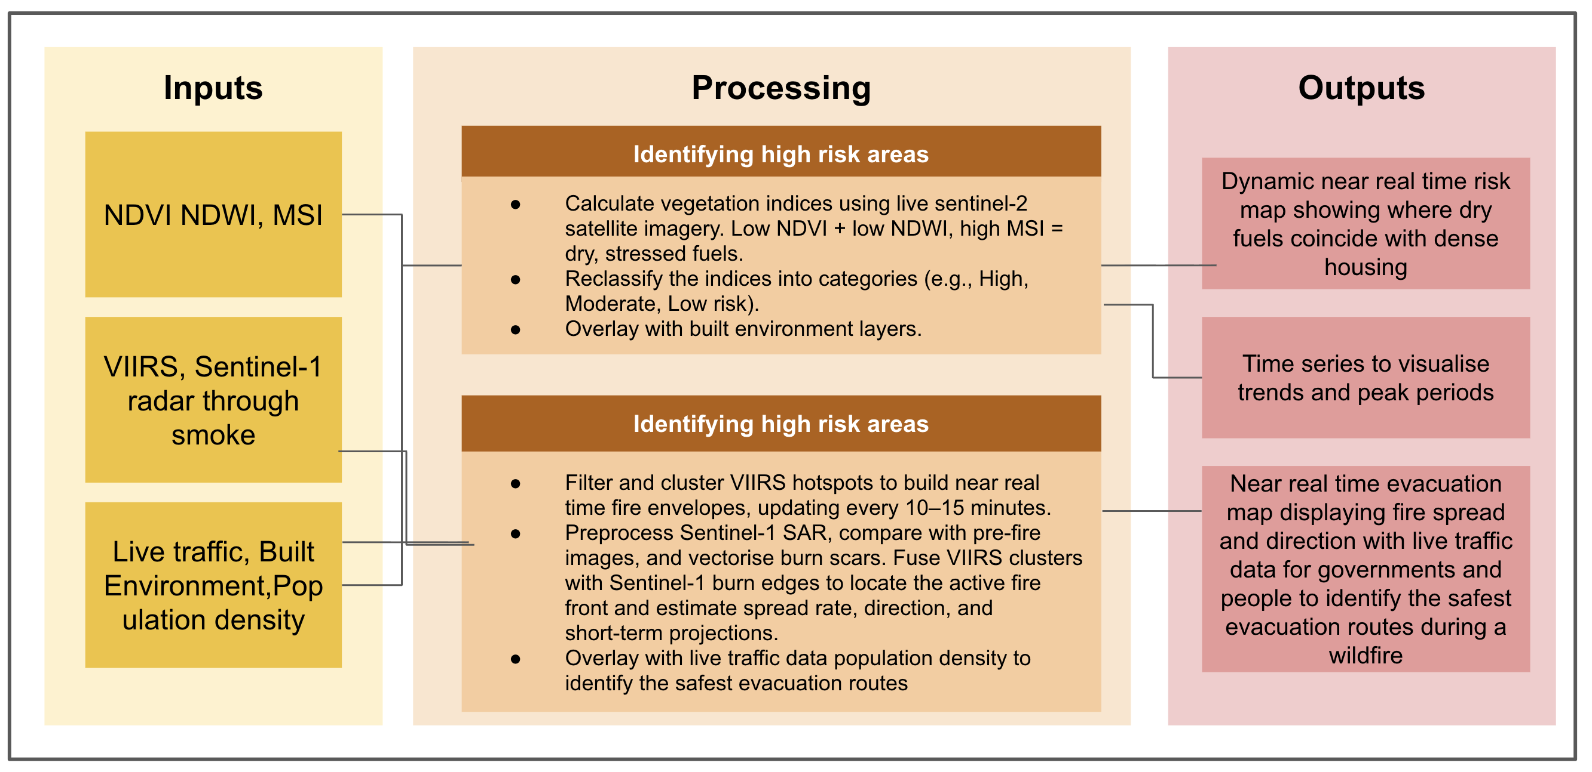

This method builds on Senate Bill 1101 by making wildfire risk mapping more dynamic and responsive. Instead of relying on static hazard zones, it uses regularly updated satellite data to show changing conditions. This means communities can plan mitigation and evacuation using information that reflects current risk.

## 4.3 Reflection:

LA is a highly developed city and one of the United States’ largest economic engines. There are many good things you can say about LA despite the heat and traffic congestion. Therefore, they must have already developed a system that can predict wildfires, right? However, although extensive academic research has examined wildfire prediction through remotely sensed data (Sayad et al., 2019; Ntinopoulos et al., 2023), the city has yet to implement such methods, including the approach I proposed. While California employs remotely sensed data to evaluate wildfire impact and map hazard zones, the resulting product remains primarily static.

Upon reflection, one potential improvement to my proposed approach would be the integration of machine learning and classification techniques to enhance wildfire prediction, as referenced in the methods above. Nonetheless, I believe this represents a strong first step toward producing a tangible outcome within a relatively short time frame, as it avoids the need for intensive analysis. Moreover, since FRAP has already utilized GEE for various visualisations, adopting this approach should be relatively feasible.

Finally, while Senate Bill 1101 represents a step forward by requiring CAL FIRE to develop products, the bill leaves a major gap in how these mandates will be carried out. It sets ambitious deadlines but does not guarantee the funding, staffing, or technical resources necessary to implement them effectively. This risks creating a cycle where outputs such as maps and reports are produced to satisfy compliance, but without the capacity to translate them into tangible wildfire resilience. In this sense, the policy is strong on vision but not on execution, limiting its potential impact.

What resonates with me from going through the policy, as an apprentice data scientist, is how often requests from senior leaders arrive with only broad direction. For instance, I might be asked to explore council priorities or measure returns on investment, but without clear guidance on what specifically should be examined or how results should be presented. This can leave analysts spending considerable time trying to interpret intentions rather than focusing on the analysis itself. Although those who do not work with remote sensing data may not grasp the technical details, more communication between decision makers and researchers can help bridge that gap. Leaders do not need to understand every step, but clearer goals and expectations make the analysis more relevant and useful.

## 4.4 References:

Aspinwall, N. (2025). ‘It’s insane to build the same thing and expect different results’: Can LA fire-proof itself? [online] Bbc.co.uk. Available at:<https://www.bbc.co.uk/future/article/20250626-can-la-fire-proof-itself>.

FRAP. (nd) *Fire and resource assessment program*, *Cal FIRE*. Available at: <https://www.fire.ca.gov/what-we-do/fire-resource-assessment-program>.

LSE (2017). In Los Angeles, the geography of where people work has been experiencing rapid change. [online]. Available at:<https://blogs.lse.ac.uk/usappblog/2017/02/22/in-los-angeles-the-geography-of-where-people-work-has-been-experiencing-rapid-change/>.

Planning, L.C. (2024) Community wildfire protection ordinance, Community Wildfire Protection Ordinance. Available at: https://planning.lacounty.gov/long-range-planning/community-wildfire-protection-ordinance/.

Senate, C. (2024) SB 1101: Fire prevention: Prescribed fire: State contracts: Maps.: Digital Democracy, Home - Digital Democracy. Available at: https://calmatters.digitaldemocracy.org/bills/ca_202320240sb1101.

Yousif, N. (2025). More than 400 indirect deaths linked to LA wildfires, study says. BBC News. [online] 6 Aug. Available at:<https://www.bbc.co.uk/news/articles/cx29wjg3vz2o>.

# 5. Week 5 - GEE

Since the first session of both my modules CASA0023 and CASA0025, I have heard about the various capabilities of Google Earth Engine (GEE). For instance calculating vegetation indices such as NDVI from large amounts of satellite imagery to track changes in land cover over time, all without putting strain on my local computer since the processing is done in the cloud. Or developing an application that visualises blast damage in vulnerable countries, as demonstrated by Ollie Balanger’s work. Now I can finally see it for myself!

**GEE is powerful geospatial software and allows us:**

1. To query data from the whole Landsat archive in seconds rather than hours.
2. To build and publish interactive maps as web applications using Earth Engine Apps.

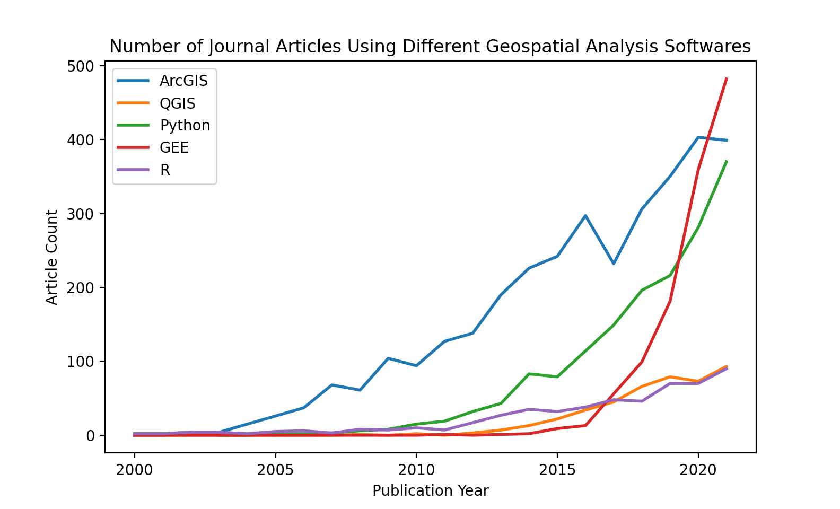

Source:[CASA0025](https://oballinger.github.io/CASA0025/)

In CASA0025 we were presented this image, which shows that since its 2015 release, GEE has surpassed other spatial software in research use and is widely applied by NGOs, universities, and international bodies.

Likewise, it is free for non-commercial and research use!

I am beginning to think the possibilities are endless…

The image below shows the Google Earth Engine interface, which consists of a code editor for writing scripts and a map window for visualising geospatial data and analysis results. Google Earth Engine also provides a vast data catalog containing satellite imagery, climate records, and other geospatial datasets that can be accessed instantly for analysis.

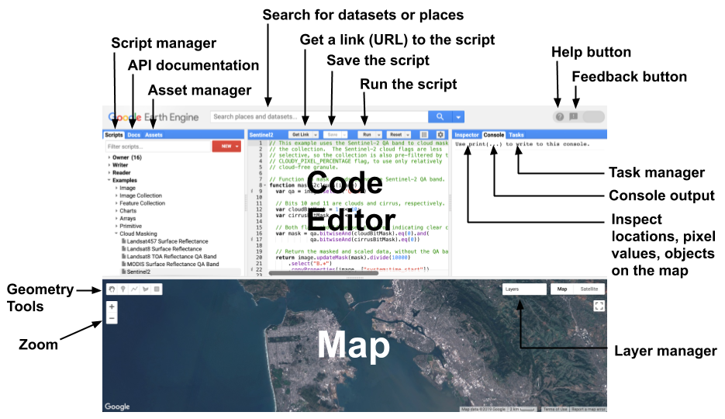 Source:[Google for Developers](https://developers.google.com/earth-engine/guides/playground)

Google Earth Engine combines vast satellite image collections with cloud computing. Users can script analyses such as NDVI, forest loss tracking, or cloud-free mosaics, with processing handled on Google’s servers and outputs delivered as maps, charts, or exports.

In Earth Engine, anything with **ee** is a server-side ‘proxy object’ meaning it doesn’t store data locally, only a reference to data on Google’s servers. Normal loops won’t work because they run locally, but the values I want to loop through aren’t actually there. Instead, you use mapping functions like .map(), which apply a function to each element of a collection on the server.

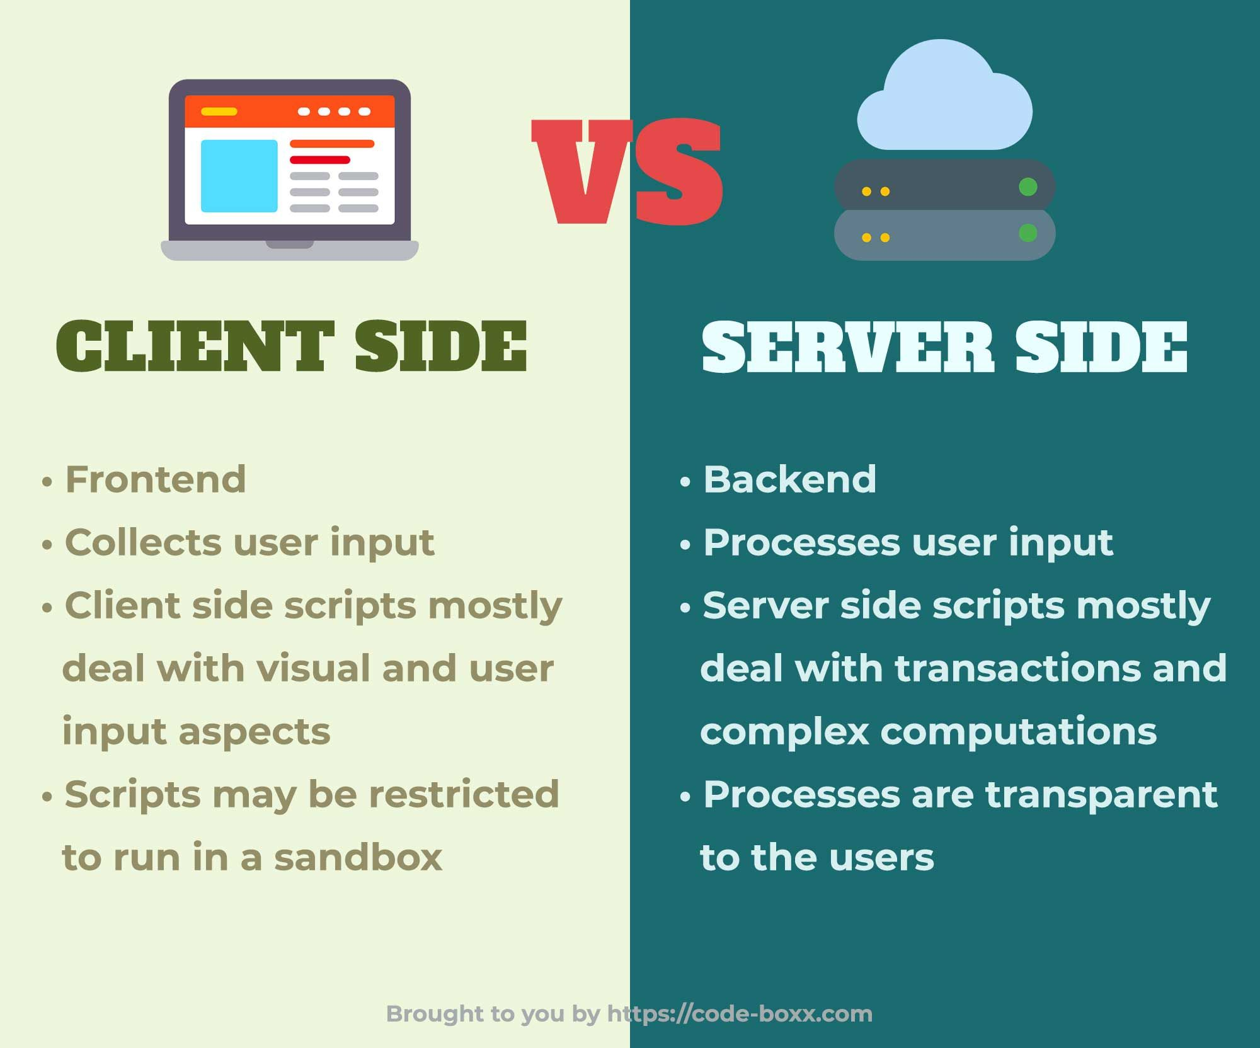 Source: [Pinterest](https://uk.pinterest.com/pin/764837949191948083/)”

This was initially quite confusing but now I understand that it’s what allows Earth Engine to process huge satellite datasets quickly by running the calculations on Google’s servers instead of my computer.

## 5.1 Applications:

Parks et al. (2018) used Google Earth Engine to develop an image merging approach for mapping fire severity across large areas. They collected all available Landsat images within a defined time window and merged them into a composite image using mean calculations to reduce noise and artefacts. From these composites, they derived burn severity metrics such as the differenced Normalised Burn Ratio and the relativised differenced Normalised Burn Ratio. This approach allowed rapid and scalable analysis compared with traditional manual or field-based techniques. However, an error in the original script produced incorrect relativised differenced Normalised Burn Ratio values. The authors later corrected the formula and updated the figures, ensuring the accuracy and reliability of their severity assessments.

Ravanelli et al., (2018) on the other hand utilised GEE and the USGS National Land Cover Database (NLCD) to monitor the impact of Land Cover Change on Surface Urban Heat Island in 6 US metropolitan areas.

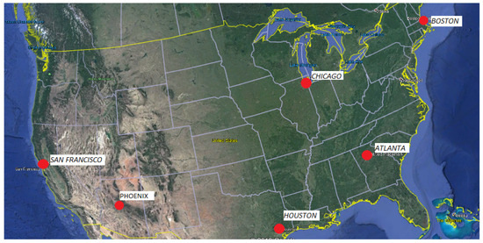

Map of cities in study (Ravanelli et al., 2018)

GEE’s ability to manage and access an extensive volume of satellite data allowed these researchers to access over 6000 Landsat images and use the Climate Engine web application to extract land surface temperature (LST) from Landsat 4-7, band 6.

Moreover, the study used pre classified Landsat data from the National Land Cover Database and grouped various land cover classes into main categories (urbanised, cultivated and grass/shrubland) and incorporated a Detrended Rate Matrix (DRM) to assess the correlation between land cover changes versus increasing temperatures. A DRM computes a baseline or average temperature trend over time and removes the influence of it allowing for a clearer understanding of how LCC impacts local temperatures.

Here you can visualise directly how urbanising increases SUHI due to the increase in LST.

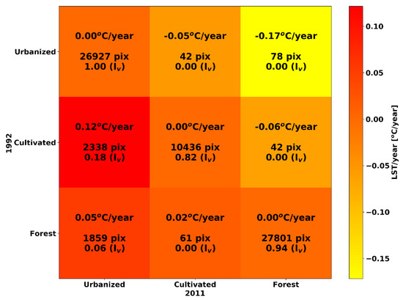

Transition matrix combining LULC and LST (Ravanelli et al., 2018)

The study noted that broad land cover groupings, such as merging residential, commercial, and industrial areas into one “Urbanized” class, may have oversimplified important urban variability in surface properties like albedo, vegetation, and heat emissions.

Both studies show that while GEE enables rapid processing of vast datasets, reliability can be undermined by coding errors in severity metrics (Parks et al., 2018) or by broad land-cover groupings that obscure urban variability (Ravanelli et al., 2018). The limitation lies less in the platform itself than in the methodological choices made within it. Future research could combine GEE’s scalability with high resolution datasets like Sentinel-2, robust classification methods, and automated validation tools to strengthen validity and transparency in large-scale environmental assessments.

## 5.2 Reflection:

This week has been very interesting since I have learned how to use a new software (GEE)and coding language (Javascript) which isn’t as difficult as I thought it would be.

The key value for me is not just speed, but the way GEE removes technical barriers: I can interrogate decades of Landsat and Sentinel imagery without relying on expensive hardware. This is directly relevant to my work for the council where fast and reliable analysis is needed for planning and environmental decisions but we don’t have the computing power to do this effectively. Likewise, as a student I can access GEE for free, but in a commercial setting the council would need to pay, which could be a barrier to using it.

Although, I am thinking about how I could use it for my dissertation. Tower Hamlets is densely built and has limited green space, so quantifying the cooling effect of vegetation is critical. Using indices such as NDVI or land surface temperature products, I could map where green cover has declined and overlay this with demographic data to identify communities most exposed to urban heat. Similarly, GEE could support routine monitoring of air quality proxies, flood-risk surfaces, or changes in permeable land cover linked to new developments. These are tasks that would be slow and resource-intensive using conventional GIS, but scalable in GEE.

That said, the platform does not eliminate uncertainty. Broad land-cover categories may mask the differences between residential, commercial, and industrial zones within Tower Hamlets, leading to oversimplified conclusions. Likewise, the coding error highlighted in the fire severity study demonstrates that small mistakes can have large consequences. For local governments, this means any GEE analysis must be accompanied by validation against ground truth or higher-resolution datasets.

In the future, I see potential in combining GEE with machine-learning methods for predictive modelling, such as forecasting where heat risk will intensify under projected land-use changes. This makes the tool not just a way of analysing historical data but a means of shaping policy in Tower Hamlets.

## 5.3 References:

Parks, S., Holsinger, L., Voss, M., Loehman, R. and Robinson, N. (2018). Mean Composite Fire Severity Metrics Computed with Google Earth Engine Offer Improved Accuracy and Expanded Mapping Potential. Remote Sensing, 10(6), p.879. doi:<https://doi.org/10.3390/rs10060879>.

Ravanelli, R., Nascetti, A., Cirigliano, R., Rico, R.V., Leuzzi, G., Monti, P. and Crespi, M. (2017). Remote Sensing-Based Urban Land Use/Land Cover Change Detection and Monitoring. Journal of Remote Sensing & GIS, 06(02). doi:<https://doi.org/10.4172/2469-4134.1000196>.

# 6. Week 6 - Classification 1

## 6.1 Summary

Before the lecture, I felt nervous as machine learning and classification seemed challenging. However, unlike GEE, these techniques have long been used in remote sensing to categorise pixels, objects, or patterns into thematic classes. Here is a very interesting example where a nonprofit organisation used satellite technology and machine learning to combat illegal fishing:

### 6.1.1 Machine learning:

Humans by nature use inductive learning: our brain provides us with information from experiences which we use to derive patterns. The more past experiences we have the better prediction we make.

Machine learning is the science of a computer modelling the human learning process.

There are various types of machine learning:

**Supervised learning:** Learning the function that relates an input and output using a training example given as input and output pairs.

**Unsupervised learning:** Learns patterns in a data set without reference to training data

**Below I break down some the methods we have discussed in the lecture in the best way I can.. Through a table (not all otherwise we’d be here forever):**

| **Name** | **Type** | **Method** | **Strengths** | **Limitations** |
| --- | --- | --- | --- | --- |
| **Classification and Regression Trees (CART)** | Supervised | Builds a decision tree by splitting data into groups based on key features; final leaves give predicted class (categorical) or value (continuous). | Easy to understand & interpret; handles both categorical & continuous data. | Prone to overfitting; unstable to small changes; lower accuracy than ensembles (e.g., Random Forests). |
| **Random Forests** | Supervised | Ensemble of CART trees built from bootstrap samples and random feature subsets; predictions combined by majority vote (classification) or averaging (regression). | High accuracy & robustness; handles large datasets; reduces overfitting. | Less interpretable (“black box”); computationally heavier; requires parameter tuning. |
| **k-means** | Unsupervised | Groups pixels into *k* clusters by assigning them to the nearest cluster center and adjusting centers until stable. | Simple & fast; works well with compact, well-separated clusters; no training data needed. | Must predefine *k*; sensitive to initial placement; struggles with irregular or noisy clusters. |

**Some key points I took from this week’s lecture:**

With higher accuracy we often lose interpretability of our models.

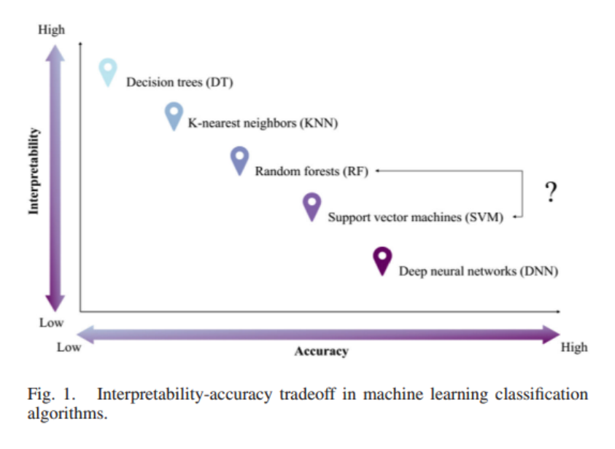

**Source:** [SHEYKHMOUSA et al. 2020 Support Vector Machine Versus Random Forest for Remote Sensing Image Classification: A Meta-Analysis and Systematic Review](https://www.researchgate.net/figure/Four-causes-of-mixed-pixels_fig3_242103275)

When running decision trees - we can see every decision that it makes.

Whereas with Random Forests - we don’t know predictions are made because while they are often accurate these models are also very complex.

## 6.2 Applications:

### 6.2.1 Supervised method:

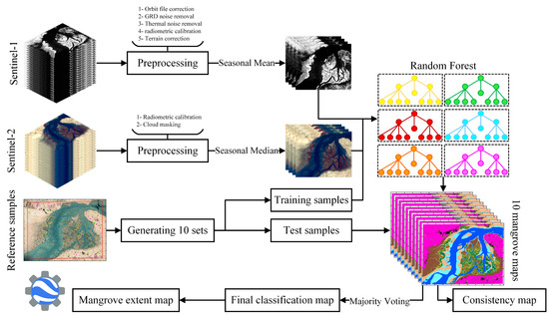

Framework of the proposed method for mangrove ecosystem mapping using the random forest (Ghorbanian et al., 2021)

Ghorbanian et al. (2021), mapped the Hara mangrove ecosystem using Sentinel-1 synthetic aperture radar data and Sentinel-2 optical data within Google Earth Engine. Nine detailed mangrove classes were identified using precise reference samples from high-resolution imagery,divided into training and testing sets with cross-validation to ensure robustness. Seasonal features reflecting tidal variations were used with a Random Forest classifier, improving classification accuracy. The approach achieved high accuracy (93.23% overall accuracy, 0.92 Kappa coefficient) and consistency, demonstrating the effectiveness of combining multi-source data and seasonal downscaling for detailed, automated, and repeatable mangrove ecosystem mapping worldwide. Supervised classification was ideal due to difficult field access, necessitating reliable reference data from imagery, and the need to differentiate detailed mangrove classes critical for ecosystem monitoring.

### 6.2.2 Unsupervised:

On the other hand Rapinel et al. (2019) used an unsupervised hierarchical TWINSPAN classifier to group vegetation relevé data into plant community types. TWINSPAN worked by repeatedly splitting the data into clusters based on species composition and identifying indicator species that defined each division. This process produced a hierarchical classification tree of vegetation units, with each relevé assigned to a cluster of similar species assemblages. The quality of these clusters was then assessed using silhouette widths, where values close to 1 indicated strong cohesion within clusters and clear separation from others. This method effectively identified consistent, locally relevant plant communities in wet grasslands, avoiding the limitations of broad, continental-scale habitat maps that often overlook fine-scale ecological patterns.

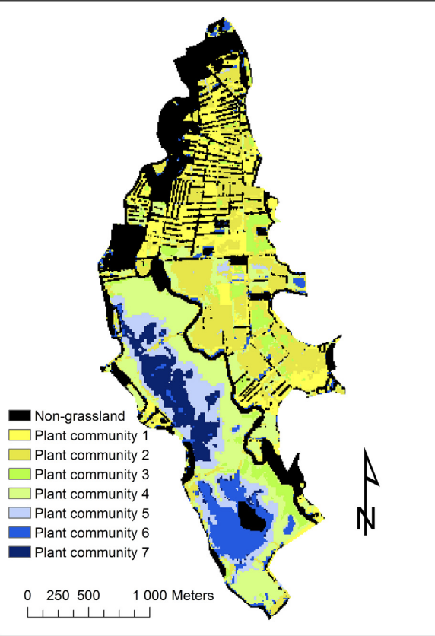

Map of plant communities derived from the classification of Sentinel-2 time-series using a linear kernel support vector machine classifier (Rapinela et al., 2019).

Ultimately, Ghorbanian et al. (2021) showed supervised methods achieve high accuracy but rely on reference data and heavy computation. Rapinela et al. (2019) highlighted that unsupervised approaches avoid this but are less transferable. Future work could explore hybrid or semi-supervised methods (Which I’m sure we will cover next week), combining the precision of supervised models with the adaptability of unsupervised ones, supported by advances in transfer learning and cloud-based platforms.

## 6.3 **Reflection:**

Machine learning has always felt inaccessible, overly technical, and far removed from practical application. However, this week changed my perspective. Rather than seeing algorithms as abstract, I began to recognise them as structured ways of organising uncertainty, enabling us to generate knowledge from complex datasets. This allowed me to move from nervousness toward curiosity.

What I found most engaging was the relevance of these methods across very different contexts. A week before the lecture, I had already tried applying K-means clustering on census data to group LSOAs in Tower Hamlets that share characteristics of poor recycling according to[ReLondon (The Mayor of London’s Recycling Team)](https://relondon.gov.uk/increase-recycling). I admit that I wasn’t really 100% sure what I was doing so I relied heavily on google. This was the output:

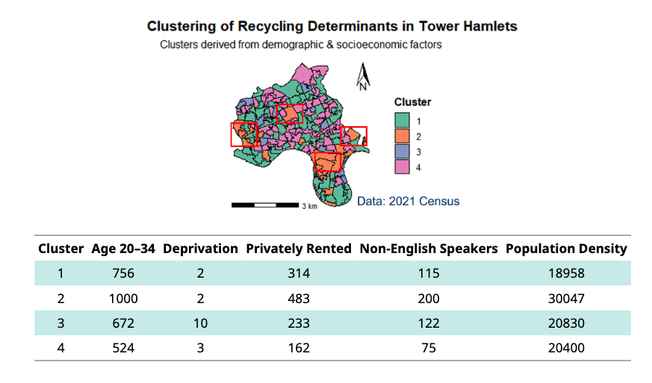

but on reflection I now recognise that K-means may not be the most appropriate method for polygon data, as it is better suited to continuous feature space rather than spatial units with irregular boundaries.

I also started to think about other ways I could apply classification and remote sensing to work. For instance, supervised learning might help map green space distribution or track patterns of development, while unsupervised approaches could identify emerging trends without the burden of extensive training data. Such possibilities suggest real scope for evidence based decision making at a local level.

The lecture also raised a critical methodological point. If training and validation data are located too closely together. This spatial dependency can lead to inflated accuracy, effectively giving the model a “sneak peek” at validation data. Unless this is accounted for through techniques such as spatial cross validation or block sampling, results may appear stronger than they truly are. The risk is particularly important in policy contexts, where misleading accuracy could undermine trust or lead to poor decisions.

Overall, I think that this week was less about memorising algorithms and more about understanding their implications. Machine learning is not simply a technical skillset but a bridge between disciplines. It holds potential for environmental monitoring, urban planning, and social policy, provided it is applied with both rigour and transparency.

## 6.4 References:

Ghorbanian, A., Zaghian, S., Asiyabi, R.M., Amani, M., Mohammadzadeh, A. and Jamali, S. (2021). Mangrove Ecosystem Mapping Using Sentinel-1 and Sentinel-2 Satellite Images and Random Forest Algorithm in Google Earth Engine. Remote Sensing, 13(13), p.2565. doi:<https://doi.org/10.3390/rs13132565>.

Rapinel, S., Mony, C., Lecoq, L., Clément, B., Thomas, A., & Hubert-Moy, L. (2019). Evaluation of Sentinel-2 time-series for mapping floodplain grassland plant communities. *Remote Sensing of Environment,* 223, 115–129. <https://doi.org/10.1016/j.rse.2019.01.018>

# 7. Week 7 - Classification 2

## 7.1 Summary:

For local analysis nothing really beats doing your own classification for that particular time point. A statement from this week’s lecture that really stuck with me. This was said when we explored the dynamic world model, which uses a semi-supervised approach to produce a global 10m resolution near real time land cover dataset. It uses surface reflectance data (which is better quality) for labelling but Top of Atmosphere for the model as it includes data from before 2017, which surface reflectance does not. The model also uses a convolutional neural network which uses an algorithm to recognise patterns in data. However, the convolutional model also does not give information about which training data is most useful. While it is useful for broader insights, if working in a local study area it is better to use your own classification or a national product.

#### 7.1.0.1 **This week we covered:**

1. **Object-based analysis** which is based on the idea that pixels are not representative of real life. Therefore groups similar pixels into meaningful vector objects which are then used to classify land cover types. However, OBIA relies on segmentation so small changes in parameters can highly impact the results.
2. Whereas, **sub-pixel analysis** does not consider a pixel to be homogeneous and considers a pixel to be made up of many components so attempts to calculate the proportion of land cover in a pixel itself. To do this we select spectrally pure end members for each land cover type and calculate fractions of each land cover inside the pixel. Which in my opinion is a better method because even 10m pixels are still likely to be heterogeneous.

We also covered accuracy because after producing an output we need to assign an accuracy value to it.

#### 7.1.0.2 **In remote sensing we focus on:**

Producer accuracy - where the classification results meet the expectation of the creator.

User accuracy - how representative the classification is of reality.

Overall accuracy

In today’s lecture we covered various accuracy assessments including Kappa, F1 and the receiver operating characteristic curve. One thing that they all had in common was:

THEY DO NOT ACCOUNT FOR SPATIAL DEPENDENCY!

‘Training’ observations near the ‘test’ observations can provide a kind of ‘sneak preview’: information that should be unavailable to the training dataset (Lovelace et al, 2022). So one thing I do know going forward is to always conduct spatial cross validation on remote sensing (as they are a spatial dataset).

## 7.2 **Application:**

In 2011 Moskal et al., published a study which used OBIA to classify land use and land cover, particularly focusing on urban tree cover in Seattle. The study utilised publicly available hyperspectral imagery from the National Agricultural Imagery Program and QuickBird (used for case study 3). It also used ancillary GIS datasets including parcel shapefiles, roads and buildings footprints. They applied a hierarchical approach using primary segmentation to separate major land cover classes, such as vegetation and impervious surfaces, using spectral, spatial, and contextual information. Within each primary class, they further subdivided the objects using different parameters (e.g., texture, shape, size) to better delineate specific features, like individual tree crowns or smaller patches of vegetation. Rule based classification was then applied to assign land cover class to extracted features.

The image below displays (a) 2002 and (b) 2009 OBIA drive classifications. Where: dark green represents tree cover, light green represents grass and fields and all other colours are impervious surfaces (grey for roads and paved areas, light brown for ground and brown for buildings.

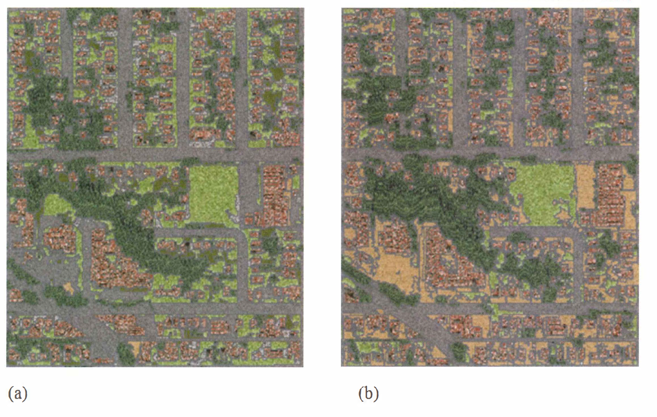

(a) 2002 and (b) 2009 OBIA drive classification (Moskal et al., 2011)

To assess the accuracy of each case study, a visual assessment using 2.54 cm resolution, 2002 aerial imagery combined with the 2009 co-registered oblique photography was conducted by an expert image analyst who was not involved in the classification process. The image below represents a confusion matrix similar to the ones we discussed in the lecture to display the accuracy assessment for case study 1.

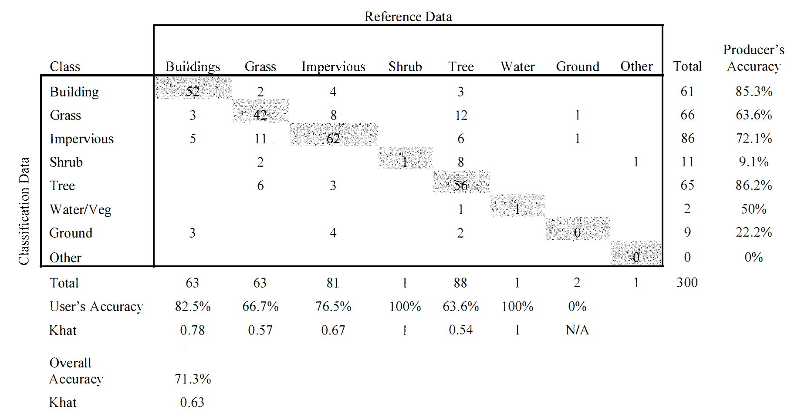  
Confusion matrix (Moskal et al., 2011)

The overall accuracy was 71.3% which is reasonably good for broad analysis, however may not be useful for fine scale analysis. Segmentation often over- or under-represented features, while spectral confusion between trees, grass, and shadows reduced accuracy. The 71.3% overall accuracy also meant nearly one in three features were misclassified. Likewise, the assessment was undertaken by a single analyst.

Ghorbanzadeh et al., however aimed to improve the detection of landslides using a combination of deep learning and OBIA. They first generated landslide probability maps with ResU-Net, which identified potential landslide areas based on pixel-level classification. then applied rule-based OBIA using geometrical features including the length-to-width ratio to distinguish between landslides and other similar looking features such as riverbeds. By integrating both approaches, they produced more accurate landslide maps, significantly improving detection performance compared to using each method alone.

## 7.3 **Reflection:**

As much as it has taken a while to wrap my head around classifications, I feel like I am finally starting to get the hang of it. I understand the theory behind OBIA and sub pixel analysis however when putting it into practice during the practical, I felt like my brain was about to explode (It was a lot to take in at once!)

Although I did finally make it to the end of the practical and produced a CART classified map layer. I still would need a lot more time to make sense of the code and more practice in google earth engine.   
  
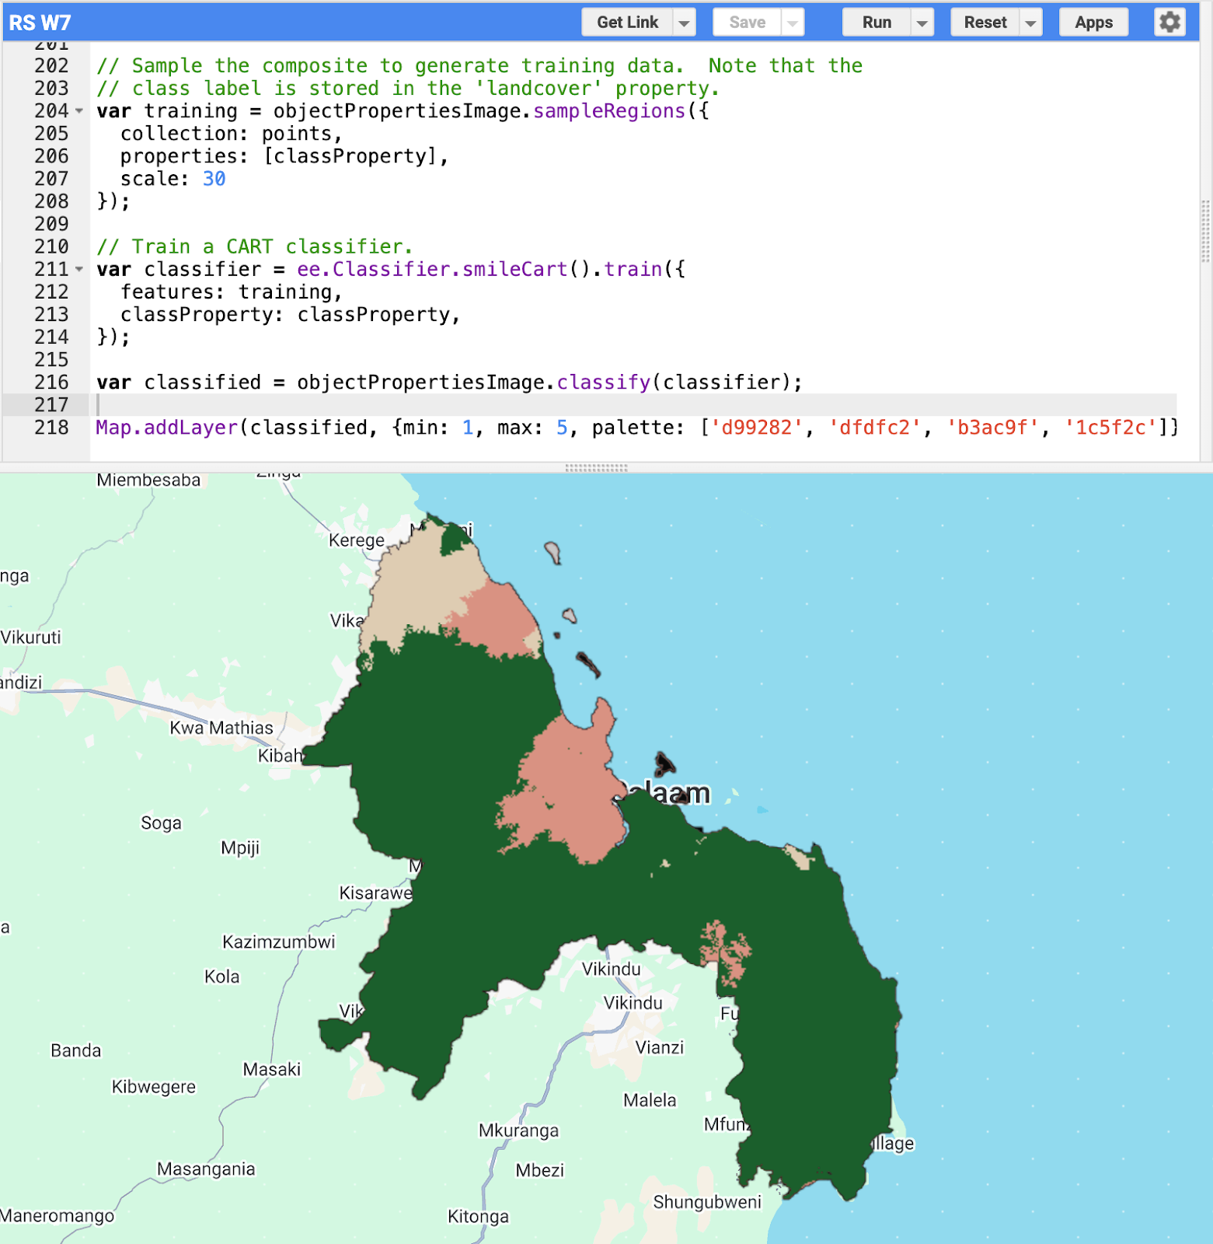

For now, based on what I understand from the material, if I were to choose a classification method I would opt for sub pixel analysis because with 30m landsat data like the one used for this week’s practical many pixels would include mixtures of land cover types. OBIA push each pixel into one class which would not work for heterogeneous blocks.

At work, these methods could be applied to monitoring how green space within urban areas changes over time. The council are often researching leisure and physical activity of residents in the borough and the topic of proximity to greenspace has come up. Likewise, Tower Hamlets is also rapidly growing in population and new developments are often being built to adapt to this. Being able to distinguish between mixed land cover types would make it easier to track whether areas that appear as open space are gradually being lost to development or whether vegetation quality within parks is declining.

## 7.4 References:

Ghorbanzadeh, O., Shahabi, H., Crivellari, A., Homayouni, S., Blaschke, T. and Ghamisi, P. (2022). Landslide detection using deep learning and object-based image analysis. Landslides, 19(4), pp.929–939. doi:<https://doi.org/10.1007/s10346-021-01843-x>.

Moskal, L.M., Styers, D.M. and Halabisky, M. (2011). Monitoring urban tree cover using object-based image analysis and public domain remotely sensed data. Remote Sensing, 3(10), pp. 2243–2262. doi:10.3390/rs3102243.

# 8. Week 8 - Temperature

## 8.1 **Summary:**

In week 5 we covered temperature and policy as my group in CASA0025 are interested in producing a heat based application, I was particularly interested in the temperature aspect.

One thing that I have learned from working in local government is that analysis needs to have a purpose. I can’t be researching something just because it is interesting as that is not a good use of time or the council’s money.

The problem in this case is the Urban heat Island (UHI) Effect - this is where urban areas obtain comparatively higher atmospheric and surface temperatures than surrounding rural areas.

**There are two main reasons for UHI’s:**

1. More dark surfaces that retain heat
2. Less vegetation that cools the environment (evapotranspiration and solar blocking).

**However many serious impacts on people and the environment:**

The body’s inability to regulate internal temperature and eliminate heat gain increases the risk of heatstroke.

The strain put on the body as it tries to cool itself also stresses the heart and kidneys, potentially worsening health risk from chronic conditions (cardiovascular, mental, respiratory and diabetes related conditions.

Heat can also disrupt and compromise essential health services, such as the loss of power supply and transport.

There is more information available on the world health organisations [website](https://www.who.int/news-room/fact-sheets/detail/climate-change-heat-and-health).

For our final learning diary entry we had the choice to choose between temperature and SAR. The reason I chose temperature was because it hits close to home. London is becoming increasingly hotter over the years and not only will it negatively impact vulnerable members of the community (my grandparents) but it will also become more extreme and threaten future generations.

In this weeks practical we explored the main sources of remotely sensed temperature data:

**Moderate Resolution Imaging Spectroradiometer (MODIS):**

MODIS is an instrument aboard both the Terra and Aqua satellites. Terra crosses the equator from N to S in the morning and Aqua S to N in the afternoon meaning the entire earth is sampled every 1-2 days, with most places getting 2 images a day. It has a resolution of 1km.

**Landsat:**

The temperature band in Landsat is B10 and as we already know it has a resolution of 30m and has a 16 day revisit cycle.

Although MODIS has a higher collection of images due to its resolution I am more likely to use Landsat as my analysis is mostly local (either the area of Tower Hamlets or London) and MODIS would not capture the spatial heterogeneity of these areas. For our casa0025 assessment we chose MODIS for this reason.

## 8.2 **Application:**

After this practical I remembered the list of awesome GEE apps we were given in week 5 [List of awesome GEE apps](https://github.com/philippgaertner/awesome-earth-engine-apps).

So naturally I went searching for an LST application and found one.

This application by [vaishnaviadhav31](https://vaishnaviadhav31.users.earthengine.app/view/land-surface-temperature) displays LST during the day in Pune, India accompanied with a timeseries. Presumably, they used MODIS as the resolution is 1km but it seems to have somewhat worked here as some differences in temperature across the city are evident. This application and others gave me a good idea of how web apps can be presented and gave me a bit more inspiration for the casa0025 module so I shared it with my group during a meeting we had to discuss the mockup of our heat vulnerability index application. Although we still have not decided whether we are using GEE to build our app or a python library called streamlit…

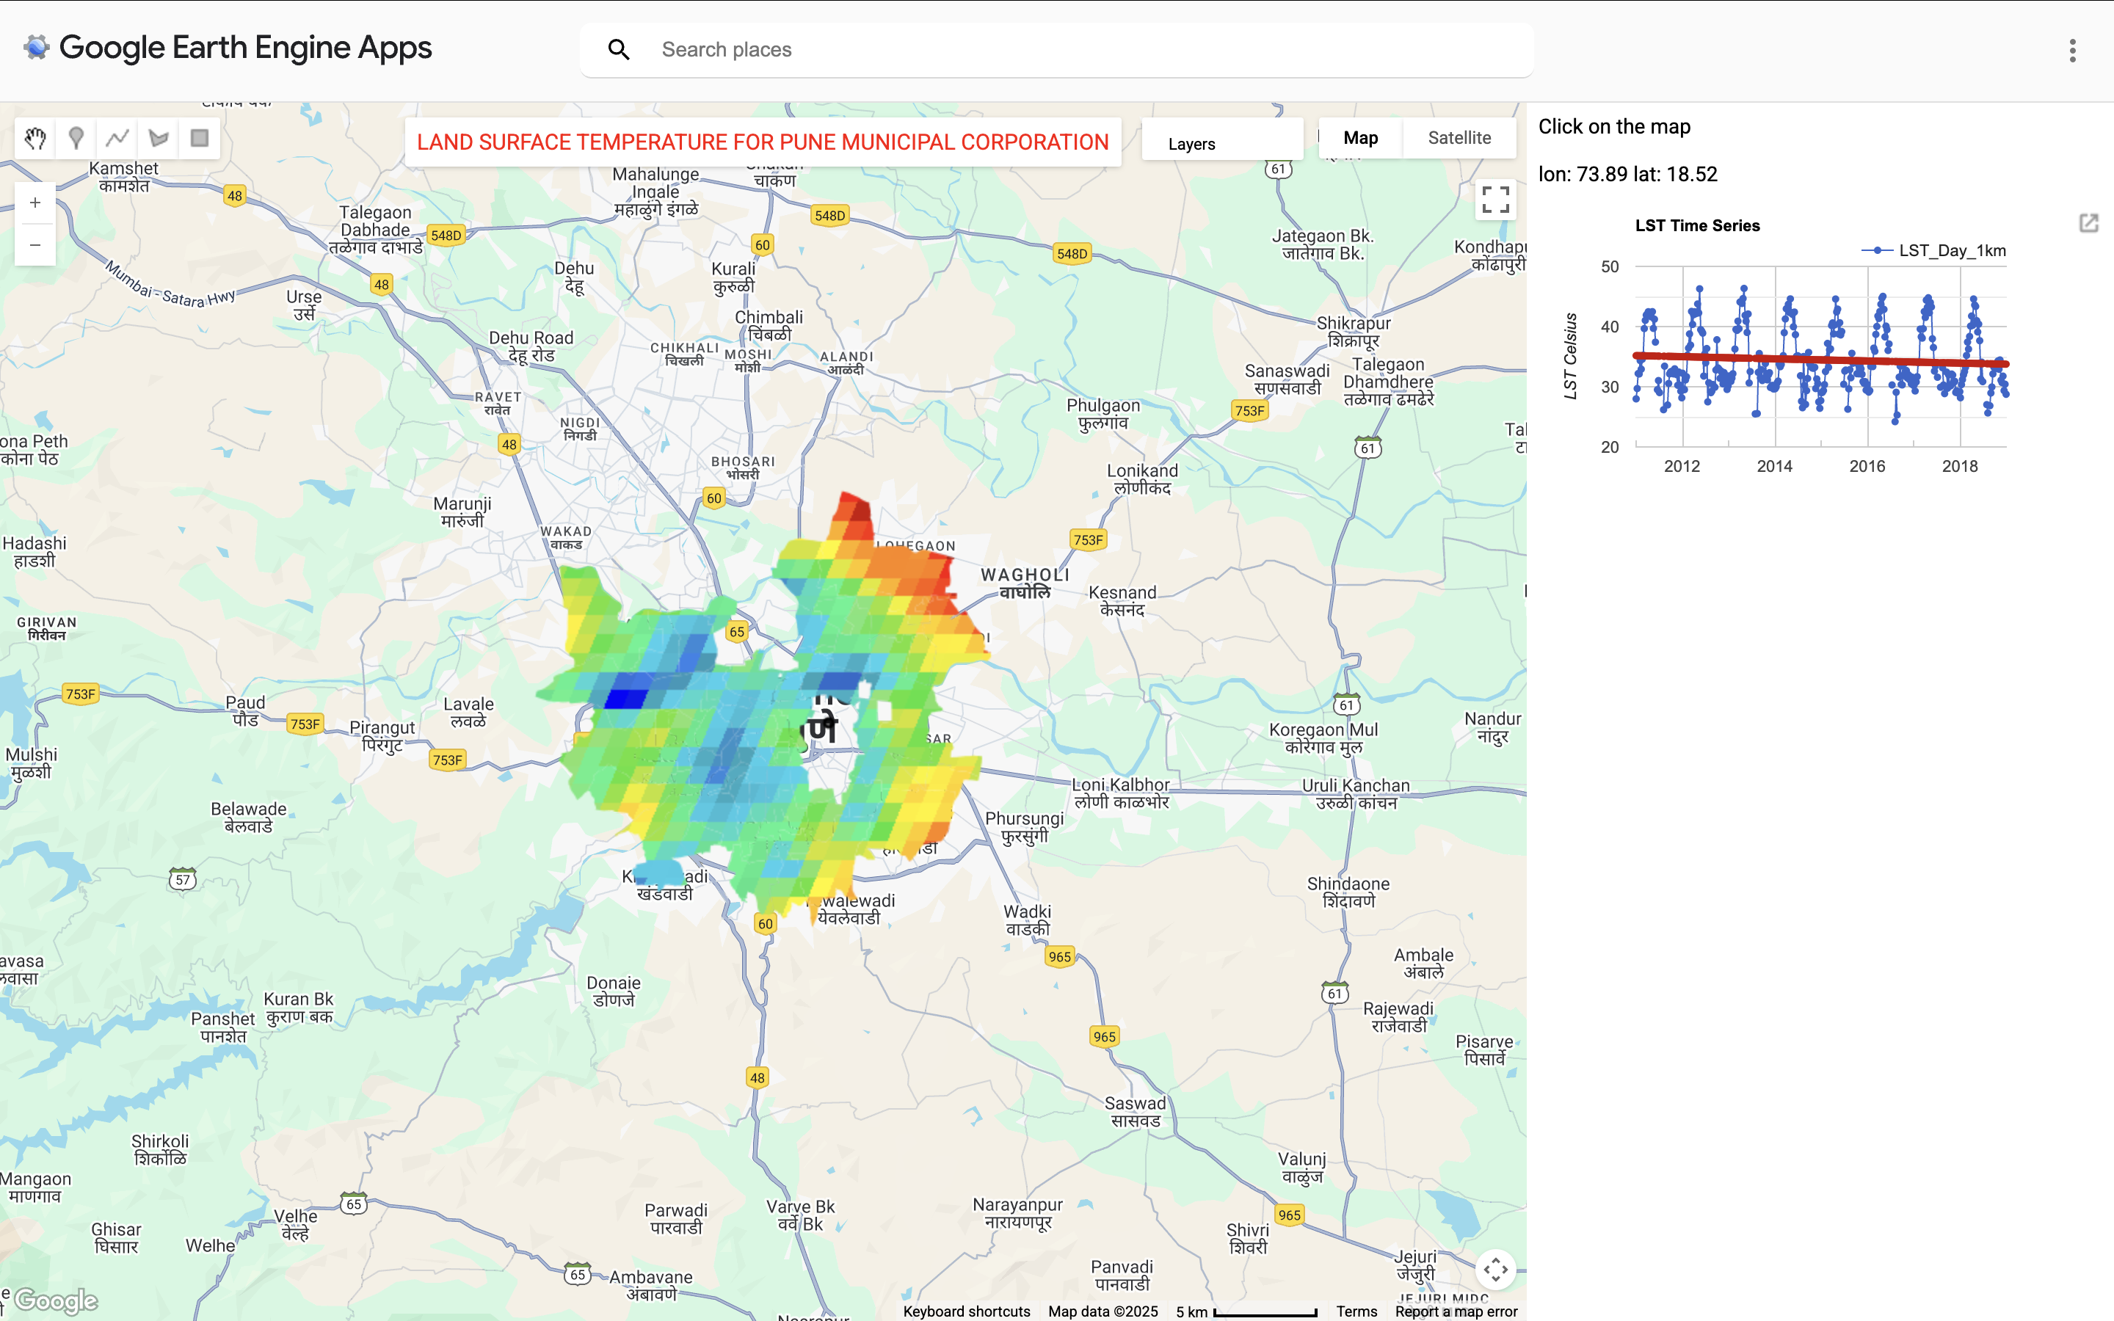

For an academic example:

In 2014 Weng et al., introduced SADFAT (Spatio-temporal Adaptive Data Fusion Algorithm for Temperature mapping), an innovative approach designed to produce high-resolution, daily Land Surface Temperature (LST) maps by integrating MODIS data with Landsat imagery. Their goal was to overcome the temporal–spatial trade-off inherent in satellite observations, where MODIS provides high temporal but coarse spatial resolution, and Landsat provides fine spatial but infrequent temporal coverage.

Landsat Thematic Map images were scaled, geometrically aligned, and resampled to match the MODIS spatial resolution. MODIS daily LST and reflectance data were then reprojected to the Landsat coordinate system using the MODIS Reprojection Tools. The SADFAT method involved first identifying spectrally similar pixels within a local window, using spectral thresholds to ensure that selected pixels shared comparable land cover characteristics. Weights were then assigned to these pixels based on both spectral similarity and temporal proximity, enabling the integration of multi-date information. Next, regression analysis was used to estimate conversion coefficients that linked radiance changes between MODIS and Landsat observations over time. These coefficients were then applied to MODIS radiance data at the prediction date, and the derived radiance values were converted into temperature estimates using Planck’s law. Finally, to enhance reliability, pixels with low confidence were masked out.

This fusion approach was tested in Los Angeles County, California, with results showing that predicted LST errors ranged from about 1.3 K to 2 K across five dates in 2005. Such accuracy demonstrates the effectiveness of SADFAT in reconciling the trade-off between spatial and temporal resolution. The method clearly enhances the spatial detail of thermal data while retaining the high temporal frequency of MODIS, making it especially valuable for applications such as urban heat island analysis, environmental monitoring, and climate impact assessments.

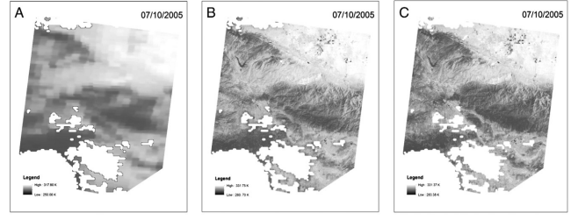

grayscale maps of Land Surface Temperature, LST (Weng et al.)

Nevertheless, the study also revealed some limitations. While SADFAT performed well in general, it struggled to fully capture rapid or unrecorded temperature fluctuations, which may occur due to transient weather conditions, localized anthropogenic activities, or sensor acquisition gaps. Despite these constraints, the approach marked a significant advancement in thermal remote sensing fusion, enabling researchers to investigate temperature dynamics at scales directly relevant to ecological processes, urban planning strategies, and public health concerns.

## 8.3 **Reflection:**

What a great way to end the module! This week has been the most interesting and useful for me because not only am I using temperature data for casa0025 but I am also particularly interested in exploring heat related health risks in Tower Hamlets for my dissertation. I am not 100% sure what I’ll be doing yet as I am on a part time course, however I hope to utalise sensor data from the council and landsat LST to predict the risk of overheating in flats, comparing permitted development flats with ones that have undergone regular planning applications. Permitted development flats are known to be [death traps](https://www.zurich.co.uk/news-and-insight/hot-homes) among the council and there has been extensive research on the negative impacts on these builds but limited on their relationship with health and heat. I really want to make an impact with my dissertation and being able to identify heat risk in a borough with some of the most vulnerable populations will in no doubt do so. Again the reason why I am most likely to use Landsat is because of its lower resolution compared to MODIS. Once I have done more research I may change my method for instance integrating MODIS with Landsat or using data that i am not currently aware of.

Moreover, although I am not a pro at using GEE yet I had some fun with replicating the[BBC heat Index on census tracts](https://www.bbc.co.uk/news/uk-62243280) in Los Angeles.

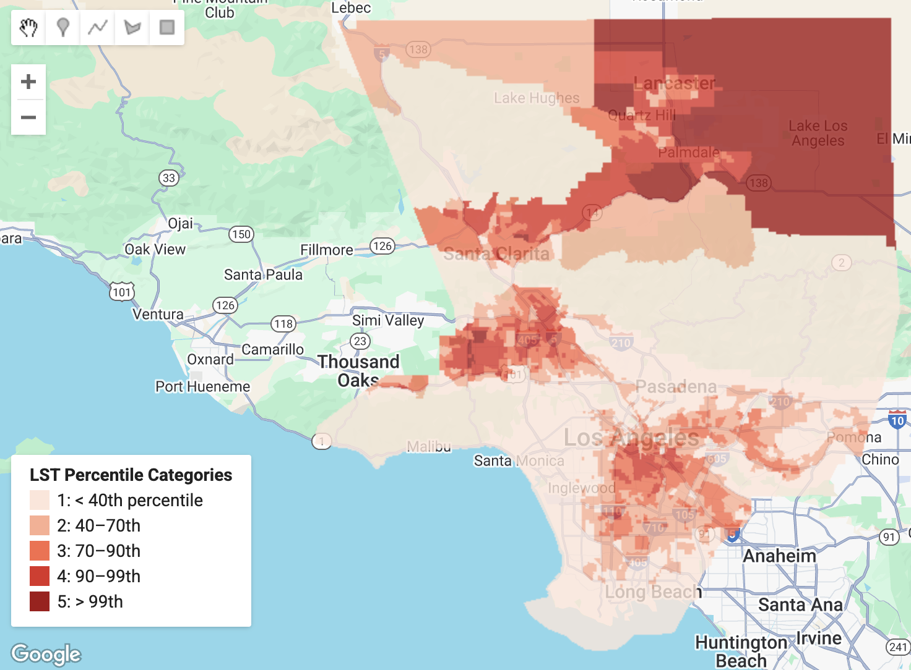

I have been playing around with it every now and again so I don’t forget what I have learned and it’s been giving me a lot more confidence with using the software.

## 8.4 References:

Weng, Q., Fu, P. and Gao, F. (2014). Generating daily land surface temperature at Landsat resolution by fusing Landsat and MODIS data. Remote Sensing of Environment, 145, pp.55–67. doi:<https://doi.org/10.1016/j.rse.2014.02.003>.

# 9. References:

Aspinwall, N. (2025). ‘It’s insane to build the same thing and expect different results’: Can LA fire-proof itself? [online] Bbc.co.uk. Available at:<https://www.bbc.co.uk/future/article/20250626-can-la-fire-proof-itself>.

Earthblox.io. (2024). Earth Blox dataset review: Dynamic World Landcover (10m) | Blog | Earth Blox. [online] Available at:<https://www.earthblox.io/resources/earth-blox-dataset-review-dynamic-world-landcover--10m>.

Ghorbanian, A., Zaghian, S., Asiyabi, R.M., Amani, M., Mohammadzadeh, A. and Jamali, S. (2021). Mangrove Ecosystem Mapping Using Sentinel-1 and Sentinel-2 Satellite Images and Random Forest Algorithm in Google Earth Engine. Remote Sensing, 13(13), p.2565. doi:<https://doi.org/10.3390/rs13132565>.

Ghorbanzadeh, O., Shahabi, H., Crivellari, A., Homayouni, S., Blaschke, T. and Ghamisi, P. (2022). Landslide detection using deep learning and object-based image analysis. Landslides, 19(4), pp.929–939. doi:<https://doi.org/10.1007/s10346-021-01843-x>.

Liu, D. and Xia, F. (2010). Assessing object-based classification: advantages and limitations. Remote Sensing Letters, 1(4), pp.187–194. doi:<https://doi.org/10.1080/01431161003743173>.

LSE , Kane, K. and Comment, regional policies|1 (2017). In Los Angeles, the geography of where people work has been experiencing rapid change. [online] USAPP. Available at:<https://blogs.lse.ac.uk/usappblog/2017/02/22/in-los-angeles-the-geography-of-where-people-work-has-been-experiencing-rapid-change/>.

Moskal, L.M., Styers, D.M. and Halabisky, M. (2011). Monitoring urban tree cover using object-based image analysis and public domain remotely sensed data. Remote Sensing, 3(10), pp. 2243–2262. doi:10.3390/rs3102243.

Ntinopoulos, N., Sakellariou, S., Christopoulou, O. and Sfougaris, A. (2023). Fusion of Remotely-Sensed Fire-Related Indices for Wildfire Prediction through the Contribution of Artificial Intelligence. Sustainability, 15(15), pp.11527–11527. doi:<https://doi.org/10.3390/su151511527>.

Parks, S., Holsinger, L., Voss, M., Loehman, R. and Robinson, N. (2018). Mean Composite Fire Severity Metrics Computed with Google Earth Engine Offer Improved Accuracy and Expanded Mapping Potential. Remote Sensing, 10(6), p.879. doi:<https://doi.org/10.3390/rs10060879>.

Planning, L.C. (2024) Community wildfire protection ordinance, Community Wildfire Protection Ordinance. Available at: https://planning.lacounty.gov/long-range-planning/community-wildfire-protection-ordinance/.

Quintano, C., Fernández-Manso, A. and Fernández-Manso, O. (2018). Combination of Landsat and Sentinel-2 MSI data for initial assessing of burn severity. International Journal of Applied Earth Observation and Geoinformation, [online] 64, pp.221–225. Available at:<https://www.sciencedirect.com/science/article/pii/S0303243417302039> [Accessed 12 Mar. 2023].

Rapinel, S., Mony, C., Lecoq, L., Clément, B., Thomas, A., & Hubert-Moy, L. (2019). Evaluation of Sentinel-2 time-series for mapping floodplain grassland plant communities. Remote Sensing of Environment, 223, 115–129. https://doi.org/10.1016/j.rse.2019.01.018

Ravanelli, R., Nascetti, A., Cirigliano, R., Rico, R.V., Leuzzi, G., Monti, P. and Crespi, M. (2017). Remote Sensing-Based Urban Land Use/Land Cover Change Detection and Monitoring. Journal of Remote Sensing & GIS, 06(02). doi:<https://doi.org/10.4172/2469-4134.1000196>.

Sayad, Y.O., Mousannif, H. and Al Moatassime, H. (2019). Predictive modeling of wildfires: A new dataset and machine learning approach. Fire Safety Journal, 104, pp.130–146. doi:<https://doi.org/10.1016/j.firesaf.2019.01.006>.

Senate, C. (2024) SB 1101: Fire prevention: Prescribed fire: State contracts: Maps.: Digital Democracy, Home - Digital Democracy. Available at: <https://calmatters.digitaldemocracy.org/bills/ca_202320240sb1101>.

Taneepanichskul, N., Hailes, H. C. and Miodownik, M., (2025). Using hyperspectral imaging and machine learning to identify food contaminated compostable and recyclable plastics. UCL Open Environment 7, 1.

Thomas, N., Simard, M., Castañeda-Moya, E., Byrd, K., Windham-Myers, L., Bevington, A. and Twilley, R.R. (2019). High-resolution mapping of biomass and distribution of marsh and forested wetlands in southeastern coastal Louisiana. International Journal of Applied Earth Observation and Geoinformation, 80, pp.257–267.

USGS (2025). What Is Remote Sensing and What Is It Used for? [online] www.usgs.gov. Available at:<https://www.usgs.gov/faqs/what-remote-sensing-and-what-it-used>.

Weng, Q., Fu, P. and Gao, F. (2014). Generating daily land surface temperature at Landsat resolution by fusing Landsat and MODIS data. Remote Sensing of Environment, 145, pp.55–67. doi:<https://doi.org/10.1016/j.rse.2014.02.003>.

World Health Organization (2024). Heat and health. [online] World Health Organization. Available at:<https://www.who.int/news-room/fact-sheets/detail/climate-change-heat-and-health>.

Yousif, N. (2025). More than 400 indirect deaths linked to LA wildfires, study says. BBC News. [online] 6 Aug. Available at:<https://www.bbc.co.uk/news/articles/cx29wjg3vz2o>.

Zhang, C., Selch, D., Xie, Z., Roberts, C., Cooper, H. and Chen, G. (2013). Object-based benthic habitat mapping in the Florida Keys from hyperspectral imagery. Estuarine, Coastal and Shelf Science, 134, pp.88–97. doi:<https://doi.org/10.1016/j.ecss.2013.09.018>.